The Marketplace Entry & Profit Map

1. Portfolio Task: The "Marketplace Entry & Profit Map"
- The Marketplace Search:
- Platform Choice: (e.g., TERAWORK, Upwork, or LinkedIn).
e.g. Platform Choice: TERAWORK (Choosing to earn in Naira for local needs).
Linkedin

- Job Selection: Paste a link or screenshot of a "Verified" job post that fits your niche.
e.g. Job Selection: [Screenshot of a Social Media Manager post with a Verified Payment Shield].
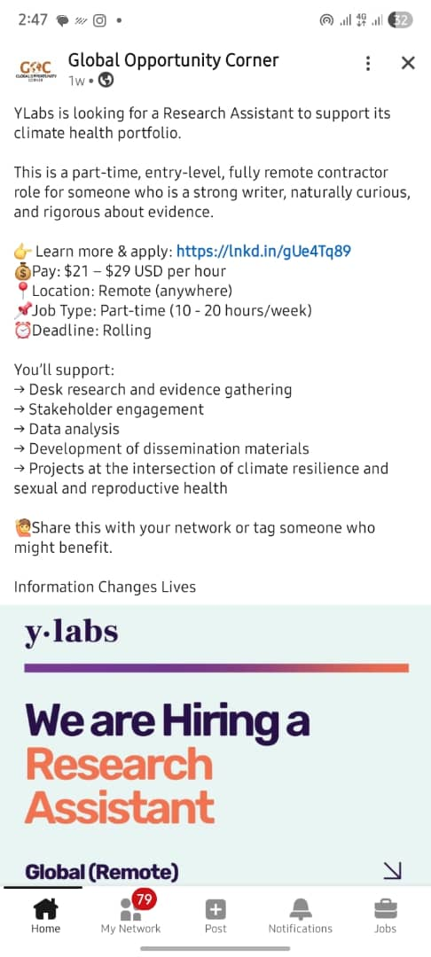

- The Hook: Write the first two sentences you would send to this specific client.
e.g. The Hook: "I see you want more people to notice and talk to your brand on Instagram. I helped a local boutique increase their comments by 40% last month, and I can do the same for you"
I see you want an Assistant manager with analytical skill, have a profesional Research experience and I am also an analyst with proficiency on SQL, Excel, Python and Power BI, I can deliver an achievable result with statistical evidences.

- Proposed Bid/Price: (e.g., ₦20,000).
e.g. Proposed Bid/Price: ₦20,000.

$29

- Estimated Data Cost (₦):
e.g. Estimated Data Cost: ₦4,000.
$4

- Estimated Power/Fuel Cost (₦):
e.g. Estimated Power/Fuel Cost: ₦3,000.
$5

- Net Profit: (Price minus Expenses): (₦)
e.g. Net Profit: ₦13,000 (This is your real income after expenses).
$20

- The Safety Check (Emeka’s Guardrails):
- Identify one "Red Flag" you will look out for in this specific niche.
e.g. Identify one "Red Flag": The client asking me to move the conversation to WhatsApp or Telegram before the contract has officially started on the platform.
The client asking my email address before the contract has officially started on the platform.

- Digital Testimony Plan: Write the exact sentence you will use to ask for a 5-star review.
e.g. Digital Testimony Plan: "I am glad we reached your goal! If you are satisfied with the service, please leave a 5-star review to help other clients find my business".
I am glad I deliver excellent result! If you are satisfied with the result, please leave a 5-star review to help other clients find me.

Full Name  Ibrahim Khalil Umar | Date of Submission  022 / 08 / 2026

